ONLINE AUCTION SYSTEM WITH REAL-TIME BIDDING

A CAPSTONE PROJECT REPORT

Submitted in the partial fulfilment for the Course of

CSA1012 SOFTWARE ENGINEERING

to the award of the degree of

BACHELOR OF ENGINEERING

IN

INFORMATION TECHNOLOGY

Submitted by

S.AMIRTHAVALLI (192521365)

Under the Supervision of

Dr. K.Anita Davamani



SIMATS ENGINEERING

Saveetha Institute of Medical and Technical Sciences

Chennai-602105

July 2026

INDEX

SNO | TITLE | PG.NO
1. | PROBLEM EXPLANATION | 6
2. | IDENTIFY KEY STAKEHOLDERS | 8
3. | ANALYZE THE CURRENT APPROACH | 10
4. | PROPOSED SOFTWARE SOLUTION USING SE PRINCIPLES | 11
5. | JUSTIFICATION OF SDLC/FRAMEWORK | 16
6. | EXPECTED OUTCOMES AND LIMITATIONS | 17
7. | CONCLUSION | 19

GIT & DOCKER TECHNICAL ASSIGNMENT
ONLINE AUCTION SYSTEM WITH REAL-TIME BIDDING

1. PROBLEM ANALYSIS
1.1 Introduction
An Online Auction System with Real-Time Bidding is a web-based application that allows users to participate in auctions through the Internet. In a traditional auction, participants need to be physically present at a particular location to place their bids. This can be inconvenient and limits participation. The proposed Online Auction System solves this problem by providing a digital platform where registered users can view auction items, participate in bidding, and identify the highest bidder.
The system provides a simple and convenient environment for conducting auctions. Users can log in to the application, view available auction items, check the current highest bid, and place a higher bid while the auction is active. The system maintains auction and bidding information and provides updated bid information to users.
The project is designed using a frontend and backend architecture. The frontend provides the user interface, while the Flask-based backend handles application logic and API requests. SQLite is used for storing application data. Docker is used to provide a consistent execution environment, and Git is used for version control and project management.
1.2 Problem Statement
Traditional auction systems require bidders to be physically present and depend heavily on manual processes. Participants may not be able to monitor an auction continuously, and maintaining bid information manually can lead to errors.
The proposed system provides an online platform where users can participate in auctions remotely. The system allows users to view auction information, submit bids, monitor the current highest bid, and complete the auction process digitally.
1.3 Project Objectives
The main objectives of the Online Auction System are:
- To develop a web-based platform for conducting online auctions.
- To allow users to securely access the auction system.
- To display available auction items and their details.
- To allow users to place bids on active auction items.
- To maintain the current highest bid.
- To maintain bidding information and auction records.
- To provide a simple and user-friendly interface.
- To use Git for source-code version management.
- To use Docker for application containerization.
- To provide a portable and maintainable application environment.
1.4 Functional Requirements
The major functional requirements are:
User Login
The system should provide a login interface through which users can access the auction system.
Auction Item Display
The system should display available auction items along with information such as item name, description, starting price, current bid, and auction status.
Bid Placement
An authenticated user should be able to enter a bid amount and submit the bid for an active auction.
Bid Validation
The system should verify that the submitted bid is valid and higher than the current highest bid.
Bid Management
The system should maintain the latest and highest bid for each auction item.
Auction Status
The system should identify whether an auction is active or has ended.
Winner Identification
At the end of an auction, the system should identify the user who has placed the highest valid bid.
1.5 Non-Functional Requirements
The system should satisfy the following quality requirements:
- Performance: Bid requests should be processed quickly.
- Availability: The application should be accessible whenever the server is running.
- Usability: The interface should be simple and easy to understand.
- Maintainability: The code should be organized into separate frontend and backend components.
- Portability: Docker should allow the application to run consistently on different systems.
- Scalability: The architecture should allow additional services and users to be supported in the future.
- Security: User access and bid-related operations should be protected from unauthorized actions.
1.6 Expected Outcomes
The expected outcome is a working Online Auction System in which users can access the system, view auction information, and participate in bidding. The application should run successfully inside a Docker container and its source code should be maintained using Git.

2. PROJECT STRUCTURE DESIGN
2.1 Repository Structure
The project repository is organized into separate folders for frontend, backend, and database-related resources.
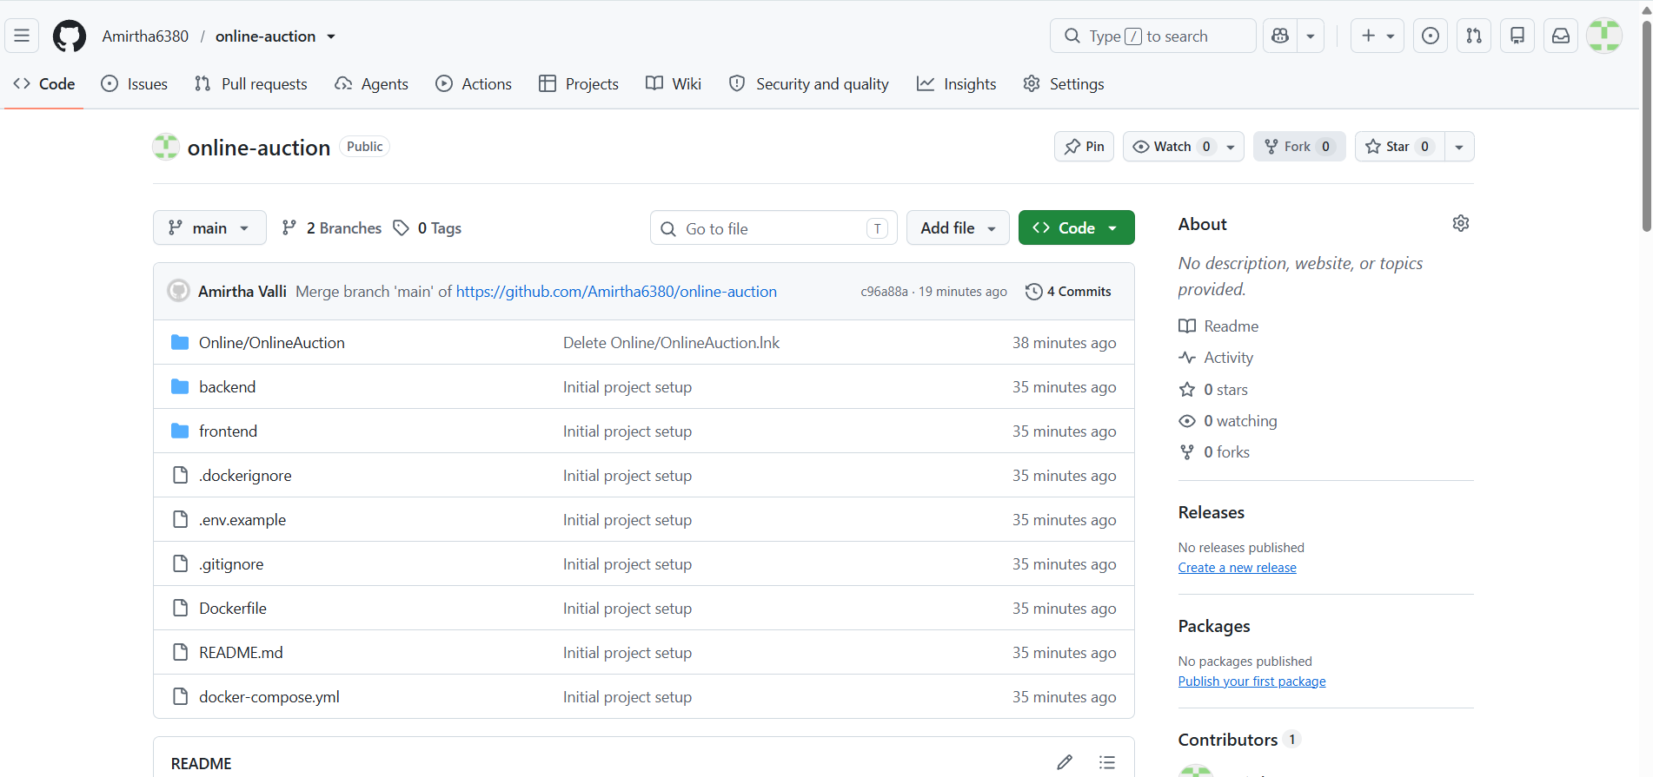
2.2 Frontend
The frontend directory contains the files responsible for the user interface.
index.html
The index.html file provides the basic structure of the web application. It contains the login interface and auction/bidding interface elements.
style.css
The style.css file is responsible for the appearance and layout of the application. It defines styles for forms, buttons, auction cards, bidding sections, and other interface components.
script.js
The script.js file contains client-side JavaScript logic. It communicates with the backend API and handles user interactions such as login, loading auction information, and placing bids.
2.3 Backend
The backend directory contains the main application logic.
app.py
The app.py file is the main Flask application. It defines API routes and connects frontend requests with backend functionality.
auction.py
The auction.py file contains auction-related logic. It is responsible for processing auction and bidding operations.
database.py
The database.py file manages database-related operations and provides the connection between the application and SQLite database.
requirements.txt
The requirements.txt file contains the Python packages required by the backend application. These dependencies are installed during the Docker image creation process.
2.4 Database
The database directory is used to store database-related files. SQLite can be used to maintain auction, user, and bidding information.
2.5 Docker and Configuration Files
Dockerfile
The Dockerfile contains the instructions required to build the application image.
docker-compose.yml
The Docker Compose file defines how the application container is built and executed.
.gitignore
The .gitignore file specifies files and folders that should not be tracked by Git.
.dockerignore
The .dockerignore file prevents unnecessary files from being copied into the Docker build context.
.env.example
The .env.example file provides an example structure for environment variables used by the application.
README.md
The README file contains information about the project, installation, execution, and usage instructions.

3. GIT REPOSITORY INITIALIZATION
Git is a distributed version control system used to track changes in source code. It allows developers to maintain different versions of a project and collaborate using branches.
The Online Auction System is maintained using a Git repository.
3.1 Repository Initialization
The local project repository was initialized using:
git init
This command creates a hidden .git directory containing Git's internal repository information.
3.2 Adding Project Files
All project files were added to the staging area using:
git add .
The staging area allows selected changes to be prepared before creating a commit.
3.3 Creating the Initial Commit
The first version of the project was saved using:
git commit -m "Initial project setup"
This created the initial version of the Online Auction System in the local Git repository.
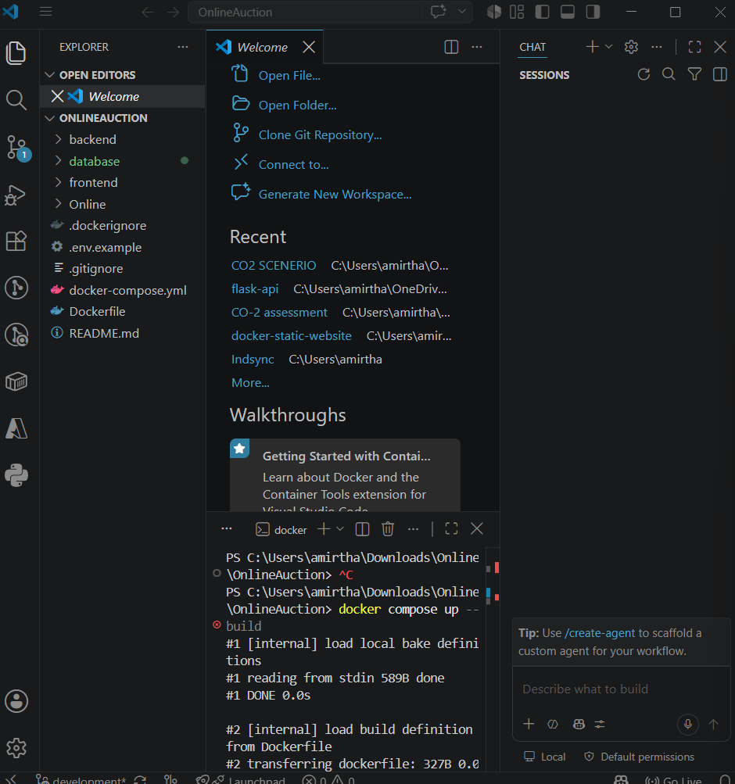
3.4 Connecting to GitHub
The local repository was connected to the remote GitHub repository using:
git remote add origin https://github.com/Amirtha6380/online-auction.git
The remote connection was verified using:
git remote -v
The repository was then synchronized with GitHub.
3.5 Main Branch
The primary branch was named main using:
git branch -M main
The main branch represents the stable version of the project.

4. GIT BRANCHING STRATEGY
A branching strategy is used to organize development and prevent unstable changes from directly affecting the stable version.
For this project, a simple branching model consisting of main, development, and feature branches is selected.
4.1 Branching Model
MAIN
│
│
DEVELOPMENT
/ | \
/ | \
FEATURE FEATURE FEATURE
AUCTION BIDDING DOCKER
4.2 Main Branch
The main branch contains the stable version of the Online Auction System. Only tested and completed changes should be merged into this branch.
4.3 Development Branch
The development branch is used for integrating and testing new features before they are added to the stable main branch.
The development branch was created using:
git checkout -b development
It was pushed to GitHub using:
git push -u origin development

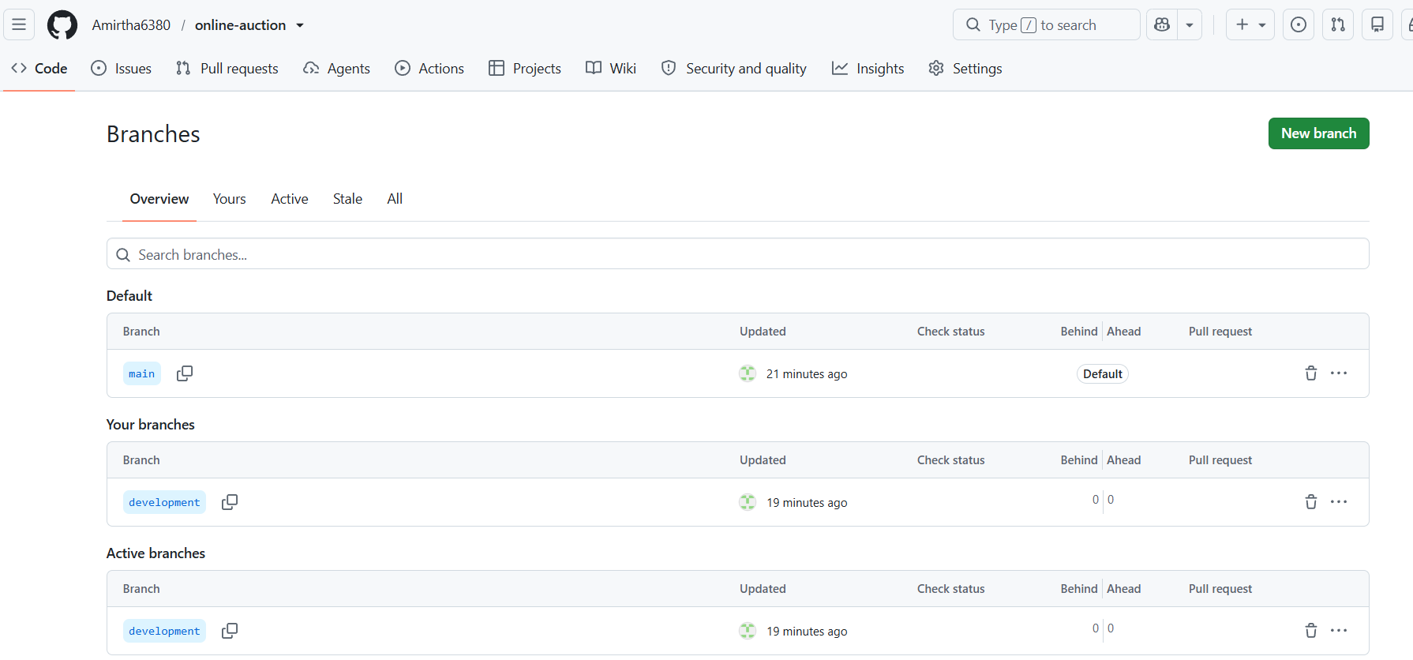
4.4 Feature Branches
Feature branches can be created for individual functionalities such as:
feature/login
feature/bidding
feature/auction
feature/docker
This approach makes development more organized and reduces the risk of unstable code entering the main branch.
4.5 Justification
This branching strategy is suitable because the Online Auction System contains several independent functionalities. Login, auction management, bidding, and Docker-related changes can be developed separately. It also provides a clear separation between stable and development versions.

5. VERSION CONTROL WORKFLOW
The Git workflow used for the project consists of creating branches, modifying files, staging changes, committing changes, pushing changes, and merging completed work.
5.1 Basic Git Workflow
Create / Modify Files
↓
git status
↓
git add
↓
git commit
↓
git push
↓
GitHub Repository
5.2 Git Status
The following command is used to check the current state of the repository:
git status
It displays modified, untracked, and staged files.
5.3 Git Add
git add .
This stages the project changes for the next commit.
5.4 Git Commit
git commit -m "Initial project setup"
A commit records a specific version of the project.
5.5 Git Push
git push -u origin main
The push operation transfers local commits to the remote GitHub repository.
5.6 Git Pull
git pull origin main --allow-unrelated-histories
This operation was used when the remote GitHub repository contained existing content that was not present in the local repository. Git combined the two histories using a merge.
5.7 Merge
Git merging combines changes from one branch into another. Merging allows completed development work to become part of the stable project.
5.8 Repository Synchronization
GitHub acts as the remote repository and provides centralized access to the project's source code. Changes can be pushed from the local system and retrieved when required.

6. COMMIT HISTORY ANALYSIS
Commit history provides a record of changes made during project development.
The project contains meaningful commits that represent important development activities.
Example commit history:
Initial project setup
Merge branch 'main'
Add database directory for Docker
Each commit represents a specific stage of development.
6.1 Importance of Meaningful Commit Messages
Good commit messages should be:
- Short
- Clear
- Descriptive
- Related to the actual change
- Easy to understand later
For example:
Initial project setup
clearly indicates that the project files were added for the first time.
A message such as:
changes
would not provide enough information about what was modified.
6.2 Commit History Command
The following command can be used to view the history:
git log --oneline
This provides a compact list of commits.
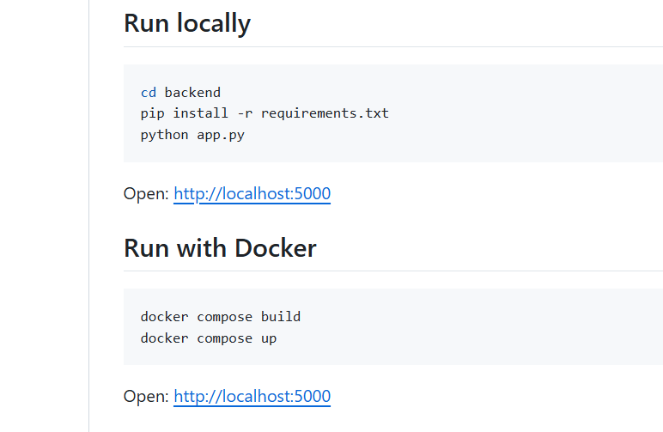
6.3 Benefits of Commit History
Commit history helps developers:
- Track project development.
- Identify when a change was introduced.
- Understand previous development decisions.
- Roll back unwanted changes.
- Maintain the project more effectively.

7. DOCKER ENVIRONMENT DESIGN
Docker is a containerization platform that packages an application together with its dependencies and configuration into a portable container.
Docker is suitable for the Online Auction System because the application requires a Python/Flask environment and specific dependencies.
7.1 Why Docker is Used
Docker provides:
- Consistent development environment
- Dependency isolation
- Easy deployment
- Portability
- Reproducibility
- Simplified application setup
- Better maintainability
Without Docker, developers may need to manually install Python, Flask, Flask-CORS, and other dependencies.
With Docker, the required environment can be created automatically.
7.2 Application Components
The main components are:
Frontend
│
▼
Flask Backend
│
▼
Auction Logic
│
▼
SQLite Database
These components are packaged into the Docker environment.
7.3 Docker Architecture
USER
│
▼
Web Browser
│
│ HTTP
▼
┌─────────────────────┐
│ Docker Container │
│ │
│ Flask Application │
│ │ │
│ ▼ │
│ Auction Logic │
│ │ │
│ ▼ │
│ SQLite Database │
└─────────────────────┘
│
▼
Port 5000

8. DOCKERFILE DEVELOPMENT
The Dockerfile defines the steps required to create the Docker image for the Online Auction System.
The project uses Python 3.11 Slim as its base image.
8.1 Dockerfile
FROM python:3.11-slim

WORKDIR /app

COPY backend/requirements.txt ./backend/requirements.txt

RUN pip install --no-cache-dir -r backend/requirements.txt

COPY backend ./backend

COPY frontend ./frontend

COPY database ./database

WORKDIR /app/backend
8.2 Explanation of Instructions
FROM
FROM python:3.11-slim
Specifies Python 3.11 Slim as the base image. The slim image provides a smaller environment suitable for running the Python application.
WORKDIR
WORKDIR /app
Sets /app as the working directory inside the container.
COPY
COPY backend/requirements.txt ./backend/requirements.txt
Copies the Python dependency file into the container.
RUN
RUN pip install --no-cache-dir -r backend/requirements.txt
Installs the required Python packages.
COPY Backend
COPY backend ./backend
Copies the backend source code into the Docker image.
COPY Frontend
COPY frontend ./frontend
Copies the frontend files into the image.
COPY Database
COPY database ./database
Copies the database directory into the Docker environment.
Final WORKDIR
WORKDIR /app/backend
Sets the backend directory as the working directory for application execution.

9. DOCKER COMPOSE DESIGN
Docker Compose is used to define and manage the application container using a YAML configuration file.
The docker-compose.yml file provides a simple way to build and run the Online Auction System.
9.1 Docker Compose Configuration
services:
auction-app:
build: .
container_name: online-auction-app
ports:
- "5000:5000"
volumes:
- auction_data:/app/database
environment:
- FLASK_ENV=production

volumes:
auction_data:
9.2 Service
The auction-app service represents the Online Auction application container.
9.3 Build
build: .
This instructs Docker Compose to build the image using the Dockerfile located in the project directory.
9.4 Port Mapping
ports:
- "5000:5000"
This maps port 5000 of the host machine to port 5000 inside the Docker container.
The application can therefore be accessed through:
http://localhost:5000
9.5 Volume
volumes:
- auction_data:/app/database
The volume provides persistent storage for database-related information.
9.6 Environment Variables
Environment variables can be used to store configuration values separately from application source code.
9.7 Networking
Docker Compose automatically creates a network for the services defined in the Compose configuration. This provides controlled communication between containers when multiple services are added in the future.

10. CONTAINER DEPLOYMENT AND TESTING
The application was successfully built and executed using Docker Compose.
10.1 Building and Starting the Application
The following command was used:
docker compose up --build
This command builds the Docker image and starts the application container.
The Docker build successfully completed and produced the application image.

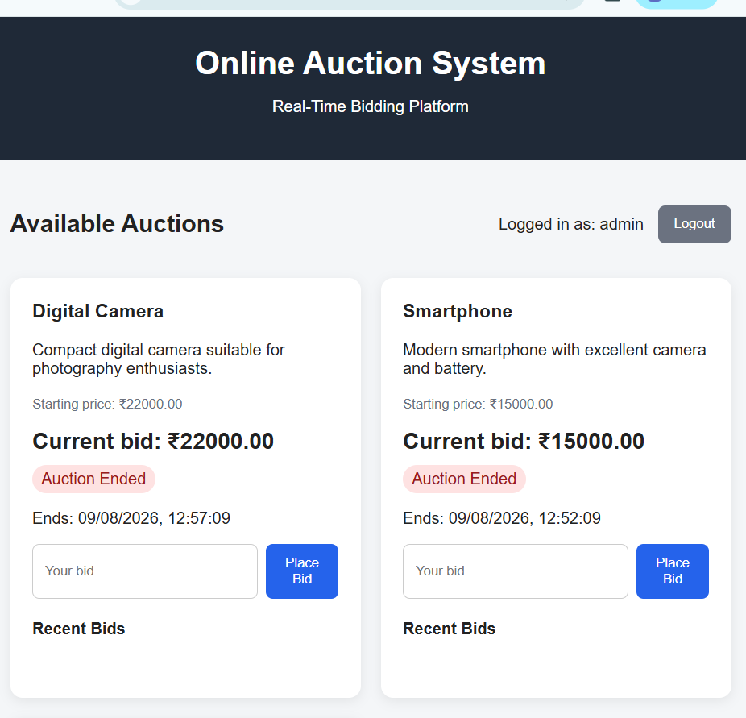
10.2 Container Creation
The Docker Compose process created:
- Docker image
- Docker network
- Docker volume
- Application container
The application container was named:
online-auction-app
10.3 Flask Server Execution
After the container started successfully, the Flask application displayed:
* Serving Flask app 'app'
* Debug mode: off
* Running on all addresses (0.0.0.0)
* Running on http://127.0.0.1:5000
This confirms that the Flask server is running inside the Docker container.
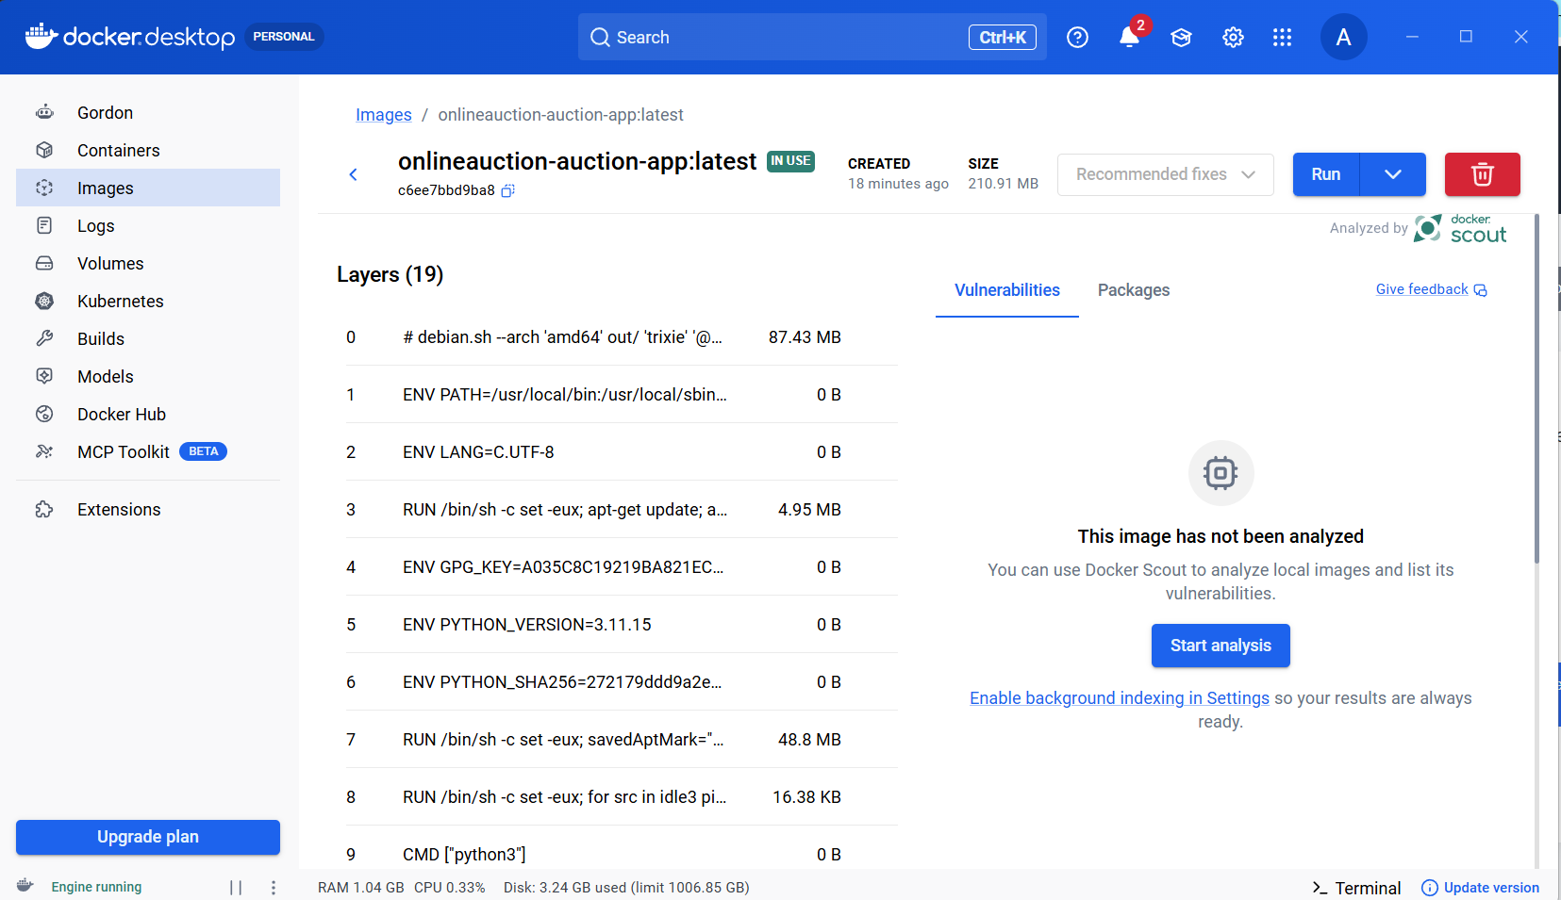
10.4 Application Testing
The application was accessed through a web browser using:
http://localhost:5000
The application provides the Online Auction System interface.
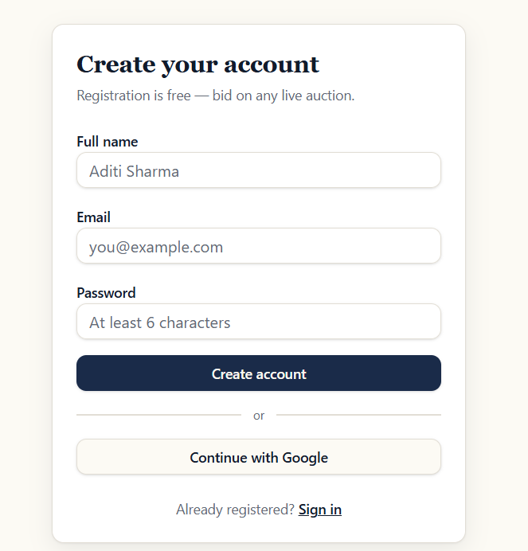

After login, the user can access the auction/bidding interface.

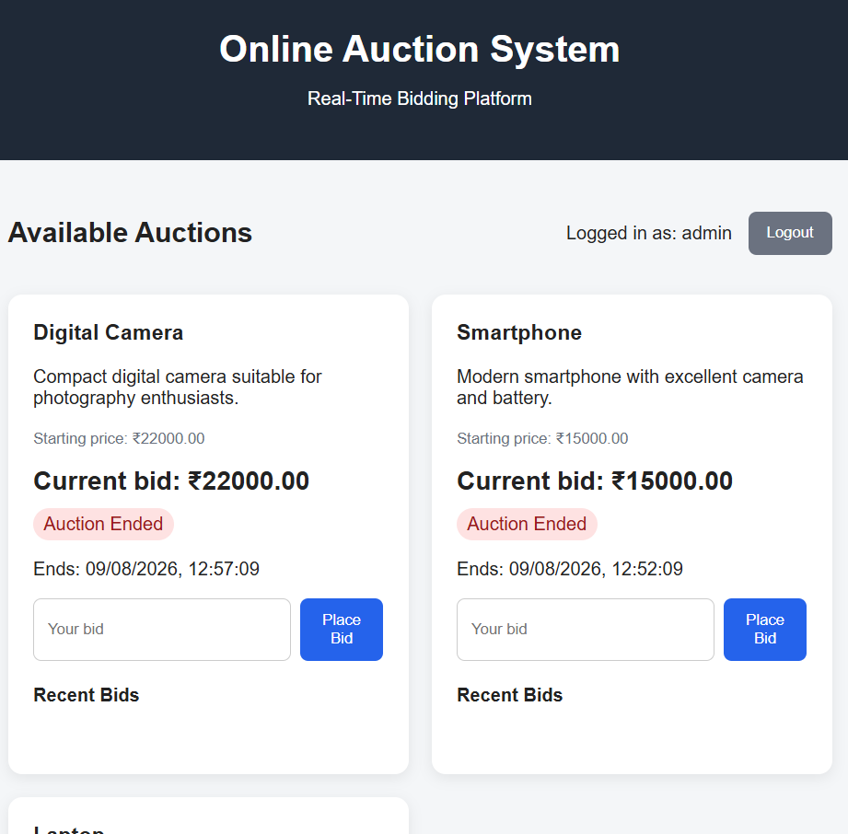

10.5 Container Verification
The following command can be used to verify running containers:
docker ps
This displays the running online-auction-app container.
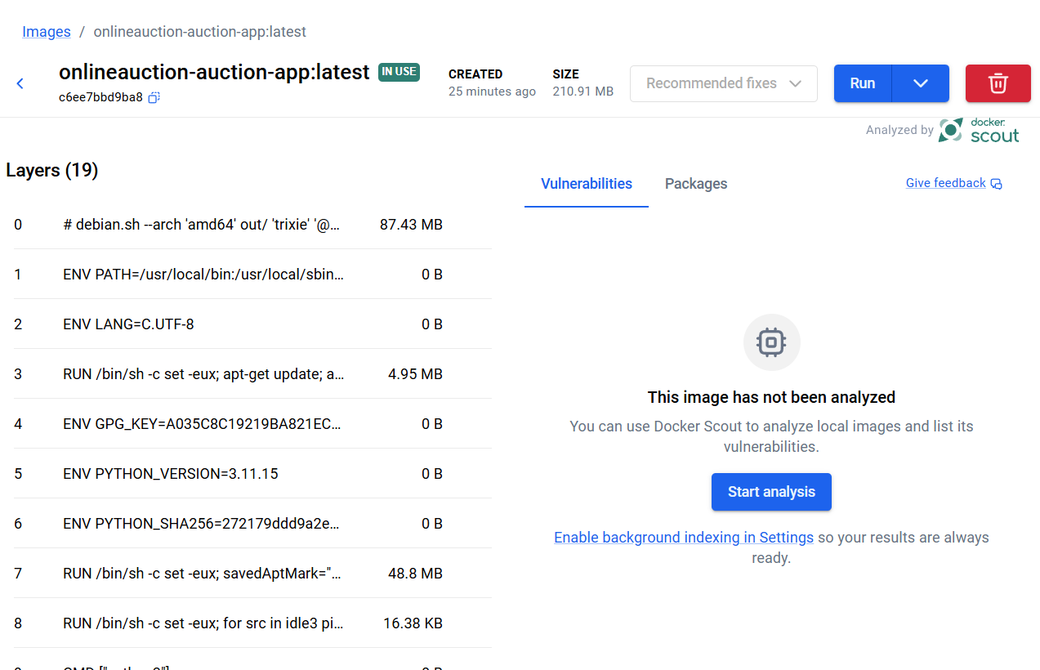
10.6 Testing Results
Test Case | Expected Result | Status
Docker image build | Image should build successfully | Passed
Container creation | Application container should start | Passed
Flask server | Server should run on port 5000 | Passed
Browser access | Application should open on localhost | Passed
Login interface | Login page should be displayed | Passed
Auction interface | Auction page should be accessible | Passed
Bid operation | Valid bids should be processed while auction is active | To be tested
Database access | Application should access database | Passed

11. BENEFITS OF GIT AND DOCKER
11.1 Benefits of Git
Version Management
Git maintains different versions of the project and allows developers to track changes.
Collaboration
Multiple developers can work on different branches and merge their work.
Branching
Feature branches allow new functionality to be developed without affecting the stable version.
Backup
The GitHub repository provides a remote copy of the source code.
Rollback
Previous commits can be used to restore an earlier version when required.
Maintainability
Commit history makes it easier to understand how the project has evolved.
11.2 Benefits of Docker
Portability
The application can run on different systems using the same Docker configuration.
Dependency Management
Python dependencies are installed inside the Docker image.
Consistency
Docker provides the same application environment across different machines.
Deployment
The application can be started using a simple Docker Compose command.
Isolation
The application runs inside an isolated container.
Scalability
The system can be extended into multiple containers in the future.
11.3 Combined Benefits
Using Git and Docker together improves the overall software development process.
Git manages the source code and versions, while Docker manages the application environment and deployment.
SOFTWARE PROJECT
│
┌──────────┴──────────┐
│ │
Git Docker
│ │
Version Control Containerization
│ │
Collaboration Portability
│ │
Change History Deployment
│ │
└──────────┬──────────┘
│
Maintainable
Application

12. CHALLENGES AND IMPROVEMENTS
12.1 Challenges Encountered
Git Remote Synchronization
Initially, the local repository and GitHub repository contained different histories. The push operation was rejected because the remote repository contained files that were not available locally.
This was resolved using:
git pull origin main --allow-unrelated-histories
The histories were then merged and pushed successfully.
Branch Management
The development branch had to be created locally and pushed to GitHub separately.
Docker Build Issue
During the Docker build process, the Dockerfile attempted to copy the database directory, but the directory was missing.
The error was:
COPY database ./database
"/database": not found
The issue was resolved by creating the required database directory.
Application Testing
The Docker container and Flask server had to be tested through the browser to verify that the application was accessible on port 5000.
12.2 Future Improvements
The following improvements can be implemented in future versions:
- Implement WebSocket technology for true real-time bidding.
- Add stronger user authentication and authorization.
- Add an administrator dashboard.
- Add auction creation and management features.
- Add automatic auction scheduling.
- Add complete bid history.
- Add payment gateway integration.
- Add email and notification services.
- Use PostgreSQL or MySQL for production deployment.
- Add Redis for faster real-time bid synchronization.
- Deploy the application to a cloud platform.
- Implement automated testing.
- Implement CI/CD using GitHub Actions.
- Add monitoring and logging.
- Improve security using HTTPS and secure authentication mechanisms.

CONCLUSION
The Online Auction System with Real-Time Bidding provides a digital platform for conducting auctions and allowing users to participate remotely. The system separates frontend, backend, and database responsibilities to improve organization and maintainability.
Git was used as the version control system to maintain project history, create branches, track changes, and synchronize the project with GitHub. The main and development branches provide a basic and organized development workflow.
Docker was used to containerize the application and its dependencies. The Dockerfile defines the application environment, while Docker Compose simplifies application deployment and execution. The successful execution of the Flask server inside the Docker container demonstrates that the application can be packaged and deployed consistently.
Overall, the combination of Git and Docker provides better version management, collaboration, portability, deployment, and maintainability for the Online Auction System. Future improvements such as WebSocket-based real-time bidding, secure authentication, payment integration, cloud deployment, and CI/CD can make the system more suitable for real-world usage.

